Post-Natural Disturbance
Forest Retention Guidance

2017 Wildfires

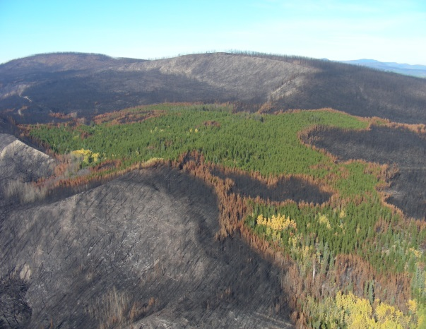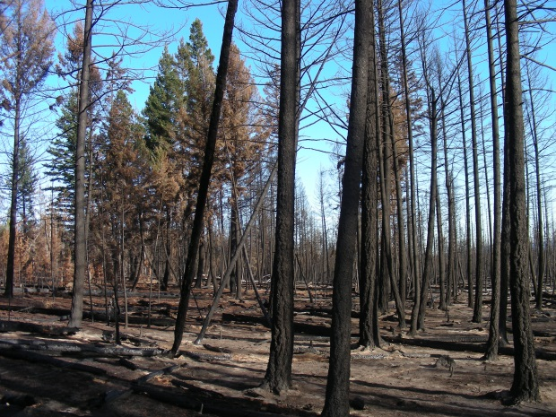

Diane Nicholls, ADM, Chief Forester
Office of the Chief Forester Division

Tom Ethier, ADM,
Resource Stewardship Division

January 19, 2018
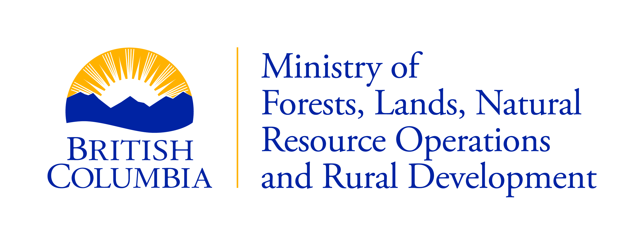

Post-Natural Disturbance Forest Retention Guidance
2017 Wildfires

Approved by:


____________________________________________ Jan. 19, 2018
Diane Nicholls, ADM Chief Forester


___________________________________________ Jan. 19, 2018
Tom Ethier, ADM Resource Stewardship Division

Cover photo, left: Southeast of Hanceville, Hanceville-Riske Creek Fire. October 26, 2017.
Cover photo, right: North of Bishop Lake, Plateau Fire. September 27, 2017.

Executive Summary
This document provides guidance for forest professionals who will plan and implement retention strategies in areas that have experienced extensive natural disturbances. Retention planning refers to the required planning for landscape connectivity, interior forest and intact ecosystem attributes (e.g., overstory trees, vegetation communities, soils and other live and decaying forest structure) that will be retained for habitat, hydrologic function, mid-term timber supply and to support recovery at stand and landscape scales. We provide this guidance now due to the need for retention planning to guide salvage logging in areas affected by the 2017 wildfires.
Wildfire is part of the natural disturbance regime in the British Columbia interior; however, at an estimated 1.2 million hectares, the 2017 wildfires are the most extensive on record. They caused significant damage to many of the things we value in the forest. The enormity of the wildfires, combined with their occurrence in landscapes already heavily impacted by insect disturbance and salvage logging, warrants a correspondingly focused and informed approach to promoting recovery of these landscapes. Salvage logging can have additional, interacting impacts on many ecosystem values that were affected by the wildfires, particularly those values related to soil productivity; habitat quality and quantity; and water quality and water regulation. While salvage logging can be a pro-active and beneficial component of a larger strategy for landscape recovery, it must be carefully coordinated with retention planning.
Retention planning is the responsibility of licensees who will conduct salvage logging. However, government expects that the planning will be done in full partnership with impacted communities and Indigenous people. Government will ensure that appropriate planning is conducted.
When planning retention during salvage logging, there are six points of overarching guidance that should be contemplated in order of priority.
- Ensure human safety and minimize damage to existing infrastructure.
- Sustain, restore or enhance the capacity of ecosystems to provide ecosystem values, such as those related to water quality and wildlife habitat.
- Consider the collective disturbances on the landscape to mitigate cumulative impacts on environmental and societal values.
- Facilitate the adaptation of forests to improve resilience to climate change.
- Minimize impacts to timber supply by shifting logging from un-damaged stands to damaged stands wherever possible.
- Recover value from the burnt timber before the wood quality deteriorates.
In general, those planning retention during salvage logging should consider human safety and the long-term provision of ecosystem values over the short-term economic gain obtained from salvaging the burnt timber. Planning should focus on what to retain, rather than on what to log.
In this document, we provide guidance on retention for specific values, and we reference other, existing and emerging sources of guidance on: planning considerations; safety; consideration of legal designations; timber supply; forest health; soil conservation and riparian management.
This guidance is additional to existing policy and guidance, which remains in effect. This guidance is provided to increase the likelihood of achieving the results-based forestry outcomes that are expected on Crown lands.

Table of Contents
Executive Summary i
Table of Contents ii
About this Document 1
1 Introduction 1
2 Retention Guidance 3
Guidance for planning retention 3
Guidance for human safety & infrastructure 4
Guidance for legally protected areas 5
Guidance for timber supply 6
Guidance for managing forest health 6
Guidance for soil conservation 7
Guidance for riparian management 8
Institutional considerations 8
Additional guidance references 8
3 The 2017 wildfires in context 10
Area burned 10
Effects on forest ecosystems and age classes, effects of burn severity on timber volume 11
Effects on special management areas 13
Forest health considerations 15
4 Effects of post-wildfire salvage logging on ecosystems and societal values 16
Ecological resilience and climate change 16
Effects on soil 17
Effects on water 18
Effects on timber and sustainable forests 19
Effects on aquatic ecosystems 19
Effects on wildlife and biodiversity 20
Uncertainty 21
Conclusion 21
Literature Cited 23

List of Figures
Figure 1. Annual area affected by wildfire provincially. 10
Figure 2. Regional area affected by the 2017 wildfires. 10
Figure 3. Age class of forest affected by wildfires; showing the area of greatest damage. 12
Figure 4. Provincial summary of age of forest burned. 12
Figure 5. Extent of wildfires in special management areas. 14

List of Tables
Table 1. Proportion of area inside the wildfire perimeters by burn severity category 11
Table 2. Volume (000s of m³) of live and dead (mountain pine beetle killed) timber in the timber harvesting landbase affected by Timber Supply Area and burn severity class 13
Table 3. Proportion of area impacted in severely affected protected areas (i.e., greater than 30% affected) 14

About this Document
This document provides government guidance from the Ministry of Forests, Lands, Natural Resource Operations and Rural Development (the “ministry”) to forest professionals designing logging plans in response to extensive natural disturbances. The wildfires of 2017 prompted the development of this document; however, the guidance is intended for general application.
Providing government guidance is a fundamental part of the professional reliance model. When tackling a new situation, and to provide clarity on government expectations for the use of Crown resources, guidance of this type enables professionals to design the appropriate solution. The objective of this guidance is to support professionals to plan and implement effective retention (see Box 1) while conducting salvage logging.
BOX 1. Retention planning: before undertaking salvage logging following natural disturbance, planning for landscape connectivity, interior forest and intact ecosystem attributes (e.g., overstory trees, vegetation communities, soils, other live and decaying forest structure) that will be retained for habitat, hydrologic function, mid-term timber supply and other values; and to support recovery at stand and landscape scales
This guidance does not replace or preclude legal requirements or other sources of guidance previously issued by the ministry.

1 Introduction
The 2017 wildfires were the most extensive on record in B.C.’s history, with an estimated 1.2 million hectares burned. Wildfires are a natural part of the ecosystems in the interior of British Columbia.¹ However, evidence suggests that large wildfires which were previously considered exceptional may now be the ‘new normal’. The incidence of large wildfires in western North America is projected to increase as the climate warms, which may result in profound changes in many ecosystems.²
The response to this ‘new normal’ must consider various social, economic and environmental factors.
- The provincial government fully recognizes the United Nations Declaration on the Rights of Indigenous Peoples (UNDRIP). The Province has made reconciliation a cross-government priority and has indicated that “…as we work together to address urgent challenges, like wildfire…response…we will embrace and implement UNDRIP in full partnership with Indigenous peoples….”³
- The most severely affected Timber Supply Areas (TSAs) (including Quesnel, 100 Mile House and Williams Lake),⁴ are experiencing substantial decreases in their Allowable Annual Cuts as the mountain pine beetle (Dendroctonus ponderosae) (MPB) outbreak and the subsequent salvage logging of dead pine concludes in those areas.⁵ The 2017 wildfires have damaged timber that was previously projected to contribute to future timber harvest (mid-term timber supply) in those areas.
- The wildfires had negative effects on many special management areas; notably Old Growth Management Areas and Ungulate Winter Ranges in the Cariboo forest region (although other areas of the southern interior were also affected; see Section 3), and likely significant negative effects on watershed functions in many areas.
- The wildfires occurred in landscapes that recently experienced a large, severe disturbance from the MPB outbreak, as well as salvage logging done to recover value from that outbreak. Post-fire salvage logging would be an additional disturbance, and it must be designed and implemented in the context of its interactions with the existing landscape condition; including previous and ongoing resource development and other natural disturbances, future climate uncertainty, and the potential of multiple, interacting disturbances that may result in a loss of ecological resilience.^{6,7}
- Salvage logging, in an effort to recover value from the damaged timber, must be expedited before the wood quality deteriorates.⁸
While the use of salvage logging can be a pro-active part of a larger strategy for landscape recovery,⁸ it must be accomplished with the greatest of care. Previous experience indicates that post-fire salvage logging often has negative effects on some ecosystem values (i.e., ecosystem services; Millennium Ecosystem Assessment⁹); particularly those values related to soil productivity,^{8,10} water quality¹¹ and water regulation¹² (Section 4). Effects on other services, for example, those related to wildlife,¹³ have been shown to be negative, neutral or positive in the face of post-fire salvage. Beyond the effects of the wildfires themselves, the potential negative effects of post-fire salvage on some ecosystem values may be difficult to remediate, may require long timelines for remediation (i.e., decades) or they may be irreversible in the context of forest management time horizons.
- Correspondingly, an environmentally focused and cautious approach to planning retention during salvage logging is warranted.
Over 22,000,000 m³ of green timber in the timber harvesting land base (THLB) may have been burned by the 2017 wildfires in the four most severely affected TSAs (Section 3). The wildfires burned an additional 12,000,000 m³ of timber that was already dead (killed by MPB; Section 3). The volume of timber killed and/or burned is substantially greater than the allowable annual cut (AAC) in the most severely affected TSAs. Given that the ‘shelf life’ of burnt timber is only two or three years,⁸ it is unlikely that all of it can be salvage logged.
- Planners should focus on what to retain, rather than on what to log.
A systematic approach to retention planning is warranted; however, this should not be construed as a call for integrated land-use planning to occur prior to commencing salvage logging. Likewise, the urgency for prompt salvage logging to recover economic value from burnt wood should not be construed as a rationale to dispense with retention planning.
- The need to plan for effective retention in short time frames to support salvage logging following natural disturbance requires a high degree of coordination, cooperation and efficiency.
The provincial government will ensure that retention planning involves the engagement of impacted communities and Indigenous people, addresses multiple values and objectives, and mitigates the cumulative impacts of resource development in affected landscapes.

2 Retention Guidance
When planning retention during salvage logging, there are six points of overarching guidance that should be contemplated in order of priority.
- Ensure human safety and minimize damage to existing infrastructure.
- Sustain, restore or enhance the capacity of ecosystems to provide ecosystem values, such as those related water quality and wildlife habitat.
- Consider the collective disturbances on the landscape to mitigate cumulative impacts on environmental and societal values.
- Facilitate the adaptation of forests to improve resilience to climate change.
- Minimize impacts to timber supply by shifting logging from un-damaged stands to damaged stands wherever possible.
- Recover value from the burnt timber before the wood quality deteriorates.
Planning retention during salvage logging in areas burned by the 2017 wildfires should place the consideration of human safety and long-term ecosystem function over the short-term economic gain obtained from salvaging timber.

Guidance for planning retention
- Forest licensees are expected to collaborate with each other, in partnership with provincial and local governments and Indigenous people, to develop coordinated, spatialized retention plans. Government will ensure that this planning occurs through:
  - the identification of forested areas that will be deferred from harvesting for a significant period of time (40 years at a minimum) and
  - patch size objectives for reserves and amalgamated harvested openings that:
    - are known, implemented and respected by all operators logging in the management unit,
    - have support for maintenance of desired landscape conditions over the long term and
    - include objectives for minimizing the extent and adjacency of large or amalgamated openings.
- All proposals for salvage logging should demonstrate how access will be managed. In general, access infrastructure built to enable salvage logging should be removed or rehabilitated as soon as possible, taking into consideration reforestation planning logistics.
- Access created during wildfire response activities, including fire guards and associated stream crossings, must be decommissioned and rehabilitated as part of any salvage logging operations conducted in an area.
- Planning should begin with maps delineating burn severity. Planners should interpret burn severity mapping in the context of the whole watershed or Landscape Unit, with consideration given to potential impacts arising from the cumulative impacts of pre-existing logging, forest health disturbances, and other resource development, in addition to the effects of the 2017 wildfires and potential salvage logging.
- Watershed-scale assessments that can be used to rate vulnerability to salvage logging should guide salvage planning where they are available. Where detailed assessments are not available, planners should rely on the results of an assessment comparable to the “level 1” analysis outlined in the “Interior Watershed Assessment Procedure Guidebook” to identify areas where there is little or no concern about increased peak flow or decreased water quality resulting from salvage logging; i.e., areas where salvage logging can be conducted without unintended consequences to water resources.
- Consider key aspects of spatial planning for fuel breaks, i.e., areas that are desirable to manage as non-forested or as low density forest in the long term (e.g., areas that are highly likely to convert to grassland or open forest, areas around communities).
- Plans for landscape-level retention should be spatially-explicit and consider the full range of ecological attributes that will support the values of interest for conservation. Considerations should include (but not be limited to) maintaining landscape-scale heterogeneity, interior forest habitat and landscape-level connectivity of wildlife habitat.
- Plan for the distribution of biological legacies across stands and landscapes. Partially damaged stands can provide unique and complex habitat. (i.e., increase the availability and variety of habitat niches). These stands may contain elements of resilience such as sources of plant propagules and soil flora and fauna, that will assist in a more rapid recovery of the stand and surrounding landscapes than what would occur if these stands were salvage logged. Retention objectives should include:
  - stands and patches of live trees;
  - a mosaic of intact unburnt and burnt patches;
  - special habitats and habitat features, particularly if they are unburned;
  - the range of burnt areas in terms of patch size, burn severity and snag density;
  - biological legacies such as large veteran trees, large snags and large coarse woody debris and
  - landscape-level connectivity of residual trees and wildlife tree patches.
- Live trees must be left on the landscape, wherever possible, even if they are within the THLB.

Guidance for human safety & infrastructure
- All areas affected by the wildfires should be screened to determine if a “Post-wildfire Natural Hazards Risk Analysis” is required. Criteria are: wildfires that are larger than approximately 50 ha; have burned with moderate or high intensity; are located above or near populated areas or transportation corridors; or are within community watersheds.
  - “Salvage [logging] should not proceed in the high or moderate hazard watersheds above elements at risk unless a further detailed study indicates that such [logging] would not exacerbate or concentrate increased surface water or overland flows.” ^{v}
- No salvage logging should occur in community watersheds or watersheds containing streams that drain directly into water licence intakes designated for drinking water, unless it can be demonstrated that the salvage logging activities will improve water quality in the affected stream reaches, or that there will be a reduction in the risk of future degradation.
- Salvaging burnt trees that may fall and damage or block roadways, powerlines, telephone lines, fence lines, rail lines and buildings, is a priority. Minimizing damage to water bodies and riparian areas should be a principal concern during these operations.
- Salvage logging around communities should be encouraged where it can be demonstrated that it contributes to objectives identified in community wildfire risk abatement plans.

Guidance for legally protected areas
- No salvage logging should be considered in ‘protected areas’ including Ecological Reserves, parks (federal, provincial, regional and local) and ‘conservation lands’ unless there is a government-approved management plan that specifically states how salvage logging will improve the value of the protected area.
- All ‘landscape-scale’ legal designations that contribute to objectives set by government under the Forest and Range Practices Act (FRPA) (with the exception of Scenic Areas, see below) should not be considered for salvage logging unless government has approved a plan that demonstrates how the value(s) covered by the designation will be retained, recovered, or improved. This guidance is consistent with other approved guidance. For example, “post-fire treatments must have the objective of restoration of [Mule Deer Winter Range] habitat.” These designations are:
- Old Growth Management Areas (OGMA);
- Ungulate Winter Ranges (UWR);
- Wildlife Habitat Areas (WHA); and
- Fisheries Sensitive Watersheds (FSW).
- Visual Quality Objectives (VQOs) are legal requirements. Management of salvage logging in these areas must remain consistent with VQOs during salvage operations.
  - Where significant activities are required to salvage and restore, or to rehabilitate, local government and impacted Indigenous people should be engaged in the discussion.
  - Areas with established Preservation or Retention VQOs may not be suitable for salvage logging, but they may be candidates for restoration.
  - In areas with Modification VQOs, salvaging beyond the usual percent alteration range, as part of a recovery plan, may be warranted.
- Where ‘non-legal’ OGMAs are referenced in Forest Stewardship Plans as a means of achieving old forest retention targets in established legal orders, they should be treated like legally established OGMAs. Legally established old forest retention targets remain legal requirements.
- The elements of this guidance on special management (conservation) areas should be considered to be minimum requirements.
- Where wildfire has destroyed the value for which the area was originally designated, and it cannot be recovered, an assessment should be conducted to determine whether a suitable replacement area can be identified and designated. Suitable replacement areas must provide for equivalent or better forest values than what was provided for in the burnt area.

Guidance for timber supply
- Marginally-impacted or non-impacted stands should be retained in order to contribute to the mid-term timber supply.
- Where stands have low to moderate levels of trees killed by fire, use only partial harvesting silviculture systems and remove only dead stems, to maximize the potential for stands to recover and contribute to the mid-term and long-term timber supply.
- In more severely damaged stands, and where the only practical silvicultural system is ‘clear cut with reserves’, design cut blocks to encompass areas where at least 70% of the timber volume has been killed by wildfire or mountain pine beetle, and place reserves in the areas with live trees.
  - Note that in some of the drier parts of the Interior Douglas-fir zone, there may be significant problems reforesting salvaged stands; particularly on steep south facing slopes.^{14,15}
  - The ability to meet reforestation obligations should be carefully considered prior to salvage logging.
- Maximize the potential to reforest damaged stands in the THLB with climate-adapted tree species and seed sources.
  - Exercise caution when designing these treatments. Particularly in stands dominated by Douglas-fir trees in very dry climates, it may be advisable not to salvage before planting in an attempt to reforest the damaged stands, given that standing dead, and large, downed trees provide microclimates that mitigate the negative effects of frost and drought on seedlings. Worker safety must be a priority in assessing these options.

Guidance for managing forest health
- Single tree “fall and burn” techniques to suppress Douglas-fir beetle (Dendroctonus pseudotsugae; DFB) are operationally impractical, and limit the effectiveness of suppression treatments across landscapes (compared to the efficacy of these treatments for MBP suppression); therefore, objectives for DFB management are to limit the spread of the beetle and to reduce future losses.
- A Douglas-fir Beetle Management Unit (DFBMU) may be delineated in the context of a landscape-level assessment of DFB hazard and risk.
- DFBMUs require:
  - a clear statement of the rationale and objectives,
  - an evaluation of risk if DFB treatments are not undertaken,
  - a statement of the expected outcomes of treatments and
  - treatment efficacy monitoring.
- DFBMU planning should involve all relevant stakeholders and consider, among other factors:
  - the landscape-level hazard and risk of DFB outbreak,
  - the season of the fire,
  - the severity of the fire,
  - the size of the trees affected and
  - whether special management areas (e.g., OGMA, UWR) or inoperable terrain are present.
- At low levels of infestation, DFBMUs can be used to attempt to protect specific values at the stand level (e.g., OGMA), by reducing the local (surrounding) risk of DFB infestations.
- DFB logging should not occur in OGMAs. Exceptions should be strictly limited to:
  - areas where there are relevant, strategic management goals and objectives set for OGMAs prior to DFB infestation, or
  - the (rare) occurrence of exceptional, extenuating circumstances.
- Integrating DFB management with retention guidance provided may result in conflicting objectives, particularly where ‘aggressive intervention’ strategies for DFB management are used. To help reconcile conflicting objectives, practitioners should plan DFB management strategies while considering the role of retention in ecosystem resilience and recovery:
  - focus DFB management in existing, developed areas to minimize new road construction;
  - use partial cutting systems wherever possible and
  - where clear cut silvicultural systems are used for DFB sanitation, design cut blocks to encompass areas where at least 70% of the timber volume has been killed by wildfire.

Guidance for soil conservation
- To address the potential sensitivity of soils in burnt areas to erosion and compaction, and concerns over terrain stability, ensure that logging will adhere to all practice requirements or results and strategies in Forest Stewardship Plans (FSPs), where appropriate; in particular, those related to soil disturbance (Forest Planning and Practices Regulation [FPPR] section 35) and site-specific terrain stability (FPPR Sections 37 and 38).
- Site-level assessments of the sensitivity of soils to salvage logging must be conducted. Suitable assessment methods are available.,
- Logging practices that limit disturbance in burnt areas, particularly in severely burnt areas, must be used (e.g., winter salvage logging on snow).
- Avoid mechanical disturbance to prevent erosion and to reduce the potential for encroachment by invasive plants and allow natural regeneration of trees, shrubs, forbs, and graminoids.
- The guidance provided for soil conservation during salvage logging in areas affected by mountain pine beetle could be used as a basis for more detailed practices.

Guidance for riparian management
- Avoid salvage logging in the Riparian Reserve Zone (i.e., the preference is to not invoke Section 51 (1)(g) of the FPPR).
- Avoid salvage logging in Riparian Management Areas (RMAs); except for rare situations in which salvaging will reduce impacts to the overall quality of the RMA for values such as water quality and aquatic habitat, in which case the following practices are appropriate:
  - where salvage logging is conducted, the timing and methods of logging should be selected so as to minimize sedimentation to any waterbody; generally, winter logging over frozen, snow covered soils is required; and
  - depending on the burn severity and degree of coupling with the hillslope, some burnt timber may be selectively logged from an RMA.

Institutional considerations
- This guidance is provided in addition to all existing, relevant policy and guidance, which remains in effect. Legal requirements are set out in FRPA, the FPPR and associated Land Use Objectives Regulation Orders and Government Action Regulation Notices. This guidance is based on the assumption that in many cases, management practices beyond the legal standards will be necessary to address government’s duty to balance multiple forest resource values in the context of the 2017 wildfires. As such, legal orders and practice requirements should be viewed as a starting place when planning for retention and salvage logging.
- Stand-level treatments intended to minimize impacts of the wildfires on timber supply may be funded by government initiatives that may have specific goals and/or requirements that result in activities not consistent with this guidance. Those initiatives include the following.
  - Forests for Tomorrow may fund the rehabilitation of previously free-growing plantations and mature forest damaged by wildfire.
  - FRPA Section 108 funding may be used to fund rehabilitation of damaged plantations that had yet to achieve free-growing status at the time of the wildfires.
  - The Forest Enhancement Society of B.C. may fund a variety of activities related to preventing and mitigating the impact of wildfires, including treating forests to improve the management of greenhouse gases under the auspices of the Forest Carbon Initiative.

Additional guidance references
Government has published several other guidance documents that may be of use when designing retention plans.
- Cariboo-Chilcotin Land Use Plan: Regional Biodiversity Conservation Strategy; Update note #14, the function and management of old growth management areas in the Cariboo-Chilcotin.
- Cariboo-Chilcotin Land Use Plan: Regional Mule Deer Winter Range Strategy; Information Note #1, Guidance for fire-damaged stands
- Guidelines for Fire Salvage Kamloops TSA (November 6, 2003)
There is also potentially relevant guidance about salvage logging in response to insect outbreaks.
- Omineca Region guidance stand and landscape-level retention for harvesting in response to spruce beetle outbreaks (September 2017)
- Guidance on Landscape- and Stand-level Structural Retention in Large-Scale Mountain Pine Beetle Salvage Operations (December 2005)
- Best Management Practices for Soil Conservation in Mountain Pine Beetle Salvage Operations
Where both wildfires and insect outbreaks have affected the landscape, planning should consider the interacting effects of both disturbances and should be based on all relevant guidance.

3 The 2017 wildfires in context

Area burned
In 2017, wildfires affected over 1.2 million hectares in British Columbia, the largest impact on record, and over eight times larger than the average annual area burned (142,000 hectares). The area affected is seventeen times larger than the long-term median, because there were relatively few, very large wildfire years; 40% of the total area affected by wildfire in the last century was the result of the 10 largest wildfire years (Figure 1).

Figure 1. Annual area affected by wildfire provincially.
Ninety-six percent of the area affected by wildfires in 2017 was in the southern interior (Cariboo, Kootenay/Boundary and Thompson/Okanagan forest regions), with 80% of the affected are in the Cariboo region. Only 40,000 hectares were burned on the coast and in the northern interior (Figure 2).

Figure 2. Regional area affected by the 2017 wildfires (Other includes the South Coast, West Coast, Skeena and Northeast regions).

It is important to understand that these estimates represent the total area within the mapped perimeter of the wildfires. However, not all of the forest in these areas was completely consumed by wildfire. Estimates of burn severity, based on satellite image interpretation, are complete for 88% of the burnt area, and show that the burns were highly variable in intensity (Table 1).
The three largest wildfires in 2017 represent over 75% of the area affected; the Plateau Fire complex (521,000 hectares), the Hanceville-Riske Creek fire (239,000 hectares), and the Elephant Hill fire (192,000 hectares) (Figure 3). The Plateau Fire complex is the largest wildfire on record in B.C.; double the size of the previous largest wildfire (a 244,000-hectare wildfire that occurred in 1958).
Table 1. Proportion of area inside the wildfire perimeters by burn severity category
Severity Category | Estimated % of volume killed* | Area (hectares) | Percent of Area
Unburned | 3 | 82,031 | 7
Low | 14 | 148,966 | 12
Medium | 27 | 340,726 | 28
High | 85 | 504,740 | 41
Known Severity Total |  | 1,076,463 | 88
Unclassified |  | 149,399 | 12
Total Area |  | 1,225,862 | 100
*Estimate of % volume killed in each category is derived from post-fire field measurements of volume loss in monitoring plots within the fire perimeter.

Effects on forest ecosystems and age classes, effects of burn severity on timber volume
The 2017 wildfires affected one million hectares of forest, nearly 2% of the forested area of the province (55 million hectares). The remaining 200,000 hectares affected by wildfire was non-forested; mostly grasslands. Nearly 80% of the forested area was mature forest (greater than 80 years old) and nearly 25% was old forest (greater than 140 years old) (Figure 4).
Nearly 75% of the area affected was in seven, primarily dry and very dry, Biogeoclimatic Ecosystem Classification (BEC) subzones/variants: IDFdk3, IDFdk4, IDFxm, MSxv, SBPSdc, SBPSxc and SBPSmk.
A total of nearly 60 million m³ of timber volume in the timber harvesting land base (THLB) was within the area affected by wildfire in the four most severely affected TSAs; (Table 2). Based on the estimated percentage of trees killed by wildfire in each severity class (Table 1), approximately 22 million m³ of timber was killed by wildfire in those TSAs and an additional 12 million m³ of timber already killed by MPB was burned during the wildfires. An additional 3.5 million m³ was affected across all severity classes elsewhere in the province.

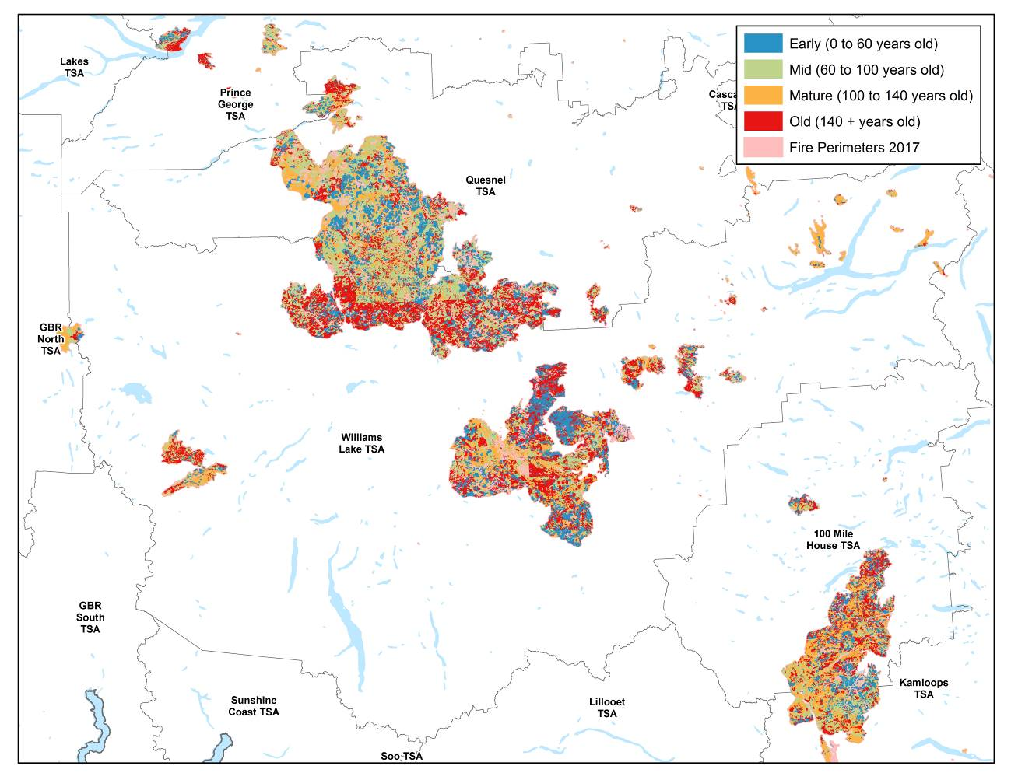
Plateau Fire complex
Elephant Hill
Hanceville-Riske Creek
Figure 3. Age class of forest affected by wildfires; showing the area of greatest damage (the Cariboo forest region) and highlighting the three largest wildfires.

Figure 4. Provincial summary of age of forest burned.

Table 2. Volume (000s of m³) of live and dead (killed by mountain pine beetle) timber in the timber harvesting landbase affected by the 2017 wildfires, by Timber Supply Area and burn severity class
 |  | Burn Severity*
Timber Supply Area | Live/Dead | Unburned | Low | Medium | High | Total
Quesnel | Live | 18 | 242 | 1,012 | 7,707 | 8,979
 | Dead | 9 | 138 | 1,007 | 6,636 | 7,790
 |  |  |  |  |  | 16,769
Williams Lake | Live | 54 | 320 | 1,079 | 6,700 | 8,153
 | Dead | 9 | 52 | 441 | 2,693 | 3,195
 |  |  |  |  |  | 11,348
100 Mile House | Live | 26 | 320 | 585 | 2,835 | 3,766
 | Dead | 3 | 49 | 130 | 658 | 839
 |  |  |  |  |  | 4,604
Kamloops | Live | 7 | 88 | 289 | 1,035 | 1,418
 | Dead | 0 | 13 | 133 | 342 | 489
 |  |  |  |  |  | 1,907
Total** | Live | 105 | 970 | 2,965 | 18,276 | 22,316
 | Dead | 21 | 252 | 1,711 | 10,329 | 12,313
 |  |  |  |  |  | 34,629
* See Table 1 for definitions of burn severity classes. Approximately 0.5 million m³ was inside the perimeter of wildfires where burn severity was not estimated.
** Approximately 3.5 million m³ was affected to varying degrees in other TSAs; notably, Prince George, Invermere and Cranbrook.

Effects on special management areas
The 2017 wildfires had a significant effect on ‘special management areas’ in the province, notably Wildlife Habitat Areas (WHAs), Ungulate Winter Ranges (UWRs), Old Growth Management Areas (OGMAs) and parks and other protected areas (e.g. ecological reserves) (Figure 5).
The only legally designated OGMAs that were affected by wildfires were in the Cariboo region, where about 15% of the OGMAs were affected (118,000 of 791,000 hectares). Throughout the rest of the southern interior, about 2% (22,000 of 1,087,000 hectares) of ‘non-legal’ OGMAs also burned.
Provincially, about 3% of the area in UWR was affected; but 6% of the area in UWR specifically designated for bighorn sheep and 8% of the mule deer UWRs were affected. In the Cariboo region, the most severely affected area, just over 10% of the UWRs were affected.
Provincially, about 1% of the area in WHAs was affected, but 22% of the area in American White Pelican WHAs was affected; the latter located around lakes in the Cariboo region.
Less than 0.5% of the area in parks and protected areas in the province was affected by wildfires, but some individual parks were severely affected (Table 3).
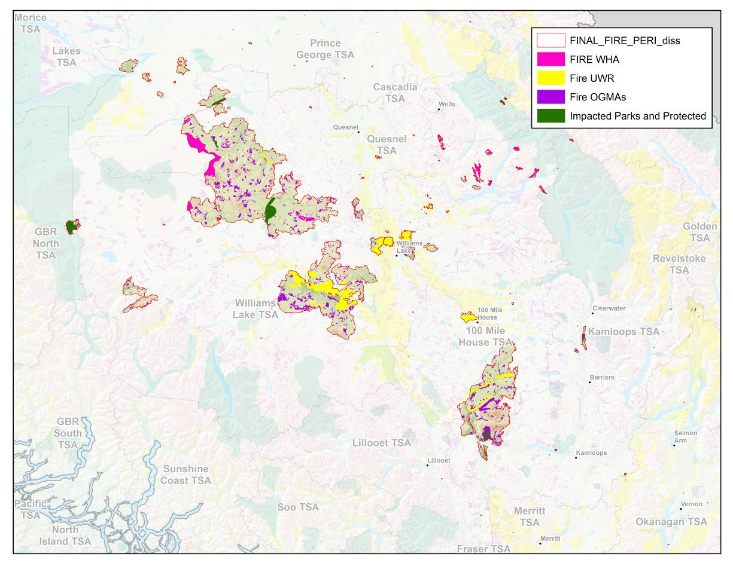
Figure 5. Extent of wildfires in special management areas in the most severely affected portion of the province.

Table 3. Proportion of area impacted in severely affected protected areas (i.e., greater than 30% affected)
Protected area name | Area affected | Total area | Percent affected
Narcosli Lake Ecological Reserve | 1,090 | 1,090 | 100%
Loon Lake Park | 3 | 3 | 99%
Arrowstone Park | 5,561 | 6,156 | 90%
Nazko Lake Park | 9,410 | 12,063 | 78%
Big Creek Ecological Reserve | 113 | 262 | 43%
Akamina-Kishinena Park | 3,505 | 10,635 | 33%
Chasm Park | 1,025 | 3,152 | 33%
Darke Lake Park | 483 | 1,504 | 32%
Elephant Hill Park | 295 | 973 | 30%

Forest health considerations
Approximately 40% of the area affected by the 2017 wildfires burned in areas that were already affected by the ongoing MPB outbreak (which began in 1999). While that infestation had largely subsided;¹⁶ mountain pine beetle populations are again increasing, with affected area up by forty percent over 2015 (to 55,000 hectares) in the southern interior.¹⁷
Spruce Beetle (Dendroctonus rufipennis) and Western Balsam Bark Beetle (Dryocoetes confusus) infestations are on the rise in BC. However, most notable in the context of the 2017 wildfires, is the significant year-over-year increase in DFB attack throughout the southern interior, with up to an eightfold increase in some areas between 2015 and 2016. Eighty-five percent of the area affected by the DFB is in the Williams Lake and 100 Mile House TSAs, although only 194 hectares of this DFB area is within the wildfire perimeters.¹⁷
Fire-damaged forest can increase the growth and severity of DFB infestations and it is likely that the current DFB infestation will increase in size, partly as a result of the 2017 wildfires. Landscape-level suppression of DFB is not practical,¹⁸ compared to the efficacy of single-tree treatments for MPB suppression across landscapes at low infestation levels. DFB treatments to suppress infestations across landscapes are ineffective; in part, related to challenges identifying green attacked Douglas-fir, and in part, related to the operational difficulty of undertaking single-tree treatments (fall and burn) on large, mature Douglas-fir trees. Objectives for DFB management are therefore focused on reducing the spread of the beetle to reduce future timber losses.
The success of implementing these objectives will depend on careful consideration of other values that may be impacted by DFB management. In particular, aggressive management strategies for DFB assume that there is a commitment by all stakeholders to support multiple, consecutive years of DFB control activities that include both short-term and long-term strategies. It is understood that Mule Deer Winter Range (MDWR), OGMA, watershed or aesthetic considerations can limit the application of aggressive management tactics and/or directed logging.

4 Effects of post-wildfire salvage logging on ecosystems and societal values
Post-wildfire salvage logging is often conducted to recover economic value in the dead and damaged trees that would otherwise be lost. Other specific objectives include: mitigating safety concerns, reducing fuels available for subsequent wildfires; reducing the incidence of forest pests and speeding the re-establishment of forest cover. While salvage logging may be an effective management response to disturbance, the degree to which these objectives can be achieved, and whether attempts to achieve them compromise other values on the landscape, remains a matter of debate. ^{8,19,20-21}

Ecological resilience and climate change
The ecological resilience of a system refers to the amount and type of disturbance an ecosystem can absorb while still maintaining its key organizing processes and structural and functional identity.^{6,22,23} In B.C. forests, key organizing processes create a range of tree species and stand ages across landscapes, creating a diversity of habitats and accordingly structuring local plant and animal populations. Resilience does not mean that systems survive disturbance, but rather, that they thrive from it; ecological resilience indicates the range of natural disturbance that maintains a system’s adaptive capacity and its tendency to self-organize and persist. ^{23–25} Ecological resilience (and ecological thresholds, or ‘non-linear change dynamics’; see Box 2^{26–29}), has emerged as the predominant framework for understanding disturbance ecology, with literature notably arising from study of the forests of western North America. ^{30–33}
BOX 2. Ecological Thresholds: At the boundaries of system capacity, ecosystems lose resilience where ecological thresholds occur - changes in key ecosystem processes that produce a markedly different condition. Ecological thresholds and the loss of resilience are of particular management concern in wildfire affected areas because breaching thresholds can cause long-lived or effectively irreversible changes on the landscape, such as loss of the ability to self-organize to the previous state. In wildfire landscapes, loss of resilience could result in shifts to grasslands, persistent shrub-dominated states or different (i.e., less desirable) forest composition and structure (e.g., lower value tree species, low density stocking).
Thresholds in the range of natural variability (Box 2) can accordingly be used to identify changes that may significantly affect the provisioning of ecosystem services. Disturbance thresholds are relevant for three reasons. First, because ecosystems may respond differently to large, infrequent disturbances than they do to smaller, more frequent disturbance of the same type.^{34,35} This implies that disturbance effects on recovery that are relatively benign at finer scales can be problematic for ecosystem functioning if they are widespread over coarser scales. For example, the removal or destruction of seed sources, if it exceeds the dispersal capacity of the species, can change local or regional vegetation composition.^{28,36} Habitat losses that can be temporarily tolerated at finer scales (i.e., habitat ‘’sinks”) can cause threshold effects on populations (e.g., rapid declines) at landscape levels if sink habitat is widespread.³⁷
Secondly, because habitat is structured by the range of natural variability in disturbance regimes at stand and landscape scales, and species have evolved within these regimes, exceeding thresholds in the rate, extent or severity of disturbance can result in threshold effects on individual species, through loss or alteration of habitat, if their minimum requirements for habitat amount, connectivity, or quality are no longer met.³⁷
Third, in addition to the implications of large, infrequent disturbances, the multiple nature of disturbance in the wildfire landscapes is of concern to disturbance thresholds in the context of recovery. The unprecedented 2017 wildfires burned in landscapes that were in the early stages of recovery from two previous, large disturbances; first, a mountain pine beetle outbreak of exceptional extent, and second, the ensuing, salvage logging operations. Ecosystems are at their lowest resilience immediately following disturbance, meaning that thresholds are most likely to be breached at this time, and that the system is less resilient to subsequent disturbance.³⁸ The empirical evidence for threshold effects caused by multiple disturbances in quick succession is in part related to climate change and the amplifying effects of the disturbance interactions, and resulting lag times in recovery or the loss of capacity to self-organize, with an increase in random, unpredictable (i.e., stochastic) outcomes. ^{22,28,39–44}
It is likely that the landscapes of the 2017 wildfires represent extremes, if not breaches, in these measures of disturbance – extent, severity, periodicity, and disturbance interactions. The relatively rapid periodicity of large, interacting disturbances (MPB, salvage, wildfire) in the landscapes of the 2017 wildfires have resulted in the presence of multiple, key factors that in other landscapes, and in the face of climate change, have led to the loss of ecological resilience. A substantial portion of the area disturbed by wildfire is predicted to change BEC variant or subzone by 2050. There is concern that the effects of these multiple, interacting landscape-scale disturbances, in conjunction with the effects of a century of natural resource development¹⁰ and current and projected changes in climate, may compromise recovery, the ecological resilience of these ecosystems and/or their resident species.^{6,7,14}

Effects on soil
Soils deserve particular attention because soils and soil productivity are irreplaceable within human time frames, and are crucial to forest recovery, stream conditions, and hydrologic processes. Post-wildfire salvage logging, unless very carefully managed, has negative effects on forest soil; over and above the effects of crown fires alone (destruction of surface organic matter causing soil erosion and loss of soil nitrogen).⁸
BOX 3. Hydrophobic Soils: when plant matter is burned during an intense fire, a waxy substance is released and it penetrates the soil as a gas. When the soil cools, this waxy substance hardens around soil particles and the soil becomes hydrophobic. Hydrophobic soils repel water and the amount of water that can infiltrate the soil is reduced.
Wildfire-affected soils are especially vulnerable to additional disturbance (e.g., compaction or increased erosion), partly as a result of changes in soil processes caused by intense burning that can produce hydrophobic soils (Box 3⁴⁵). Post-wildfire salvage logging can further damage soils by compacting them, by removing vital organic material, and by interacting with hydrophobic soil conditions to increase the amount and duration of topsoil erosion and runoff, which in turn harms aquatic ecosystems. The potential for damage to soil and water resources is high when ground-based machinery is used.^{10,46}
Another concern is the potential for increased erosion susceptibility associated with site preparation to control competing vegetation and remove slash. Site preparation techniques which inhibit growth of vegetation may contribute to increased hillslope erosion in high-risk areas, especially when increased rainfall occurs.²⁰ Erosion impacts of road construction are among the main impacts of post-wildfire salvage logging on soil when the surface has been bared by wildfire. Skidding logs across bare ground disturbs and compacts soil. However, while compaction can be detrimental on clay-based soils, on sandy soils compaction may enhance plant growth.⁸ Tractor logging and ground-based equipment on relatively level areas (<30 percent slope) cause the most soil compaction, although some effects can be mitigated by avoiding wet soils, logging over snow, and operating over slash rather than areas with thin forest floors.⁸

Effects on water
Wildfires cause the loss of forest cover which can result in reduced interception of precipitation and increased snow accumulation amounts. Snowmelt rates may also increase due to increased net radiation, and reduced transpiration rates can result in increased soil erosion. These effects result in greater soil/groundwater recharge and greater runoff in the burnt watersheds during spring melt.^{11,47} Following wildfire, numerous changes in water quality are possible, with variable rates of recovery. Potential effects include increased turbidity, nutrients (e.g., nitrogen and phosphorus), dissolved organic carbon, heavy metals (e.g., mercury), and temperature.⁴⁷ As discussed above, intense wildfires can create hydrophobic soils that impede water infiltration into the soil profile, creating a functionally shallow soil. Wildfire-induced hydrophobicity is transient and often patchy.⁸
All of these effects can be amplified by salvage logging activities; especially the construction of roads, logging with ground-based equipment and cable yarding.^{8,10,11,47} In a well-studied set of watersheds in western Alberta, sediment production was elevated in burnt and salvage-logged watersheds (nine and 37 times greater, respectively) compared to unburnt catchments. This effect has shown no recovery in the 11 years since the wildfire.¹¹ Dissolved organic carbon (DOC) and turbidity are water quality parameters that are important to drinking water providers. In the area, DOC concentrations of 4–5 mg/l (near or above which is known to pose additional water treatment challenges) were exceeded in salvage-logged, burnt and unburnt catchments about 50%, 8%, and 4% of the time, respectively. Turbidity exceeded the 10 Nephelometric Turbidity Unit (NTU) threshold about 18%, 10%, and 2% of the time, respectively.¹¹ Long-term sedimentation impacts were also found following wildfire salvage in the western U.S., where sedimentation differences between control and ground-skidded plots worsened over time as the control plots recovered more rapidly.⁴⁸
These results indicate that salvage logging may cause significant difficulties for water purveyors. Protection of source water may be more effective and less expensive than dealing with the impacts of salvage logging through increased levels of post-logging rehabilitation.⁴⁷
Changes in hydrology can contribute to a statistically significant increase in numbers of landslides, floods, debris flows and other mass-movement events in susceptible terrain, following severe wildfire in snow-dominated environments.¹² Post-wildfire salvage logging may increase mass wasting and deliver more terrestrial sediment to stream channels than burnt watersheds without salvage logging. Salvage logging may increase the risk of sedimentation regardless of equipment type and amount of traffic. The increased sediment production and consequent deterioration in water quality associated with salvage should be understood as a trade-off against the positive values of salvage logging.⁴⁹
Specific best management practices are needed to mitigate the hydrologic impacts of post-wildfire salvage logging to reduce the impacts on post-wildfire sediment production and delivery to the stream network.^{46,48} The potential for salvage logging to cause soil disturbance should be considered in consultation with soils specialists prior to commencing any operations.⁵⁰

Effects on timber and sustainable forests
Research indicates that a possible outcome of multiple, interacting disturbances under a changing climate may be a shift to lower-value forests; for example, the prevalence of species with lower timber values or lower-density forests.^{28,40,44} This is a particular concern given the dominance of dry ecosystems affected by the wildfires,⁵¹ and there is speculation that similar effects may be observed in BC.⁵² Post-wildfire salvage logging has been shown to have both negligible⁵³ and negative effects on succession,⁵⁴ leading to conclusions that best management practices are necessary to mitigate the negative effects of salvage logging, such as leaving post-wildfire biological legacies in situ (i.e., intact, in place),⁵⁴ and logging over snow to limit damage to soils and understory vegetation.⁵³
Post-wildfire logging can significantly reduce future surface woody fuel depending on the volume and sizes of wood removed; logging methods; post-logging fuel treatments; and the amount of coarse woody debris left on site to support wildlife habitat, erosion control, and other management objectives.⁵⁵ However, despite the removal of large woody fuel,⁵⁶ forests that were burned and then salvage logged have been shown to be at a risk of re-burning with high severity because of altered condition of the forest vegetation and changed forest fuels, particularly fine fuels.⁵⁷ An analysis of 1,500 wildfires in the western U.S. showed that forests with high levels of retention burned less severely than other, logged forests.⁵⁸
In any case, if post-wildfire salvage logging is to be an economically viable proposition it must be done soon after the wildfire has occurred. Trees killed or badly damaged by wildfire begin deteriorating immediately, and commercial value declines rapidly. Decay fungi infect sapwood within the first year, and sapwood usually has no commercial value by the second or third year. Weather deterioration causes longitudinal splits (checks) that are usually minor in large standing dead trees, but smaller trees or species with thin bark may be affected more extensively.⁸ Despite relatively rapid declining timber value, the rate of salvage must be balanced against strategies to retain other social and environmental values on the landbase.

Effects on aquatic ecosystems
Even small changes in water quality can have significant impacts on aquatic ecology, resulting in greater algal production, increased aquatic invertebrate abundance, and shifts in invertebrate community structure.⁴⁷ Increased runoff and erosion resulting from salvage logging alters river hydrology by increasing sediment loads and the frequency and magnitude of high flows. These changes alter the character of river channels and may cause harm to a range of aquatic species.^{10,59}
The behaviour of wildfires in riparian zones is complex and results in a variety of responses; many riparian organisms can recover rapidly after wildfires. Unless constrained by other factors, fish may not be affected¹¹ or will rebound relatively quickly. Erosion events associated with wildfires can contribute wood and coarse sediment that can create and maintain productive aquatic habitats.⁴⁷
Given that wildfire in riparian areas creates conditions that may not require intervention to sustain long-term productivity, post-wildfire riparian zones should be provided with the same environmental protections they received before they burned.⁶⁰

Effects on wildlife and biodiversity
The effects of wildfires on wildlife and biodiversity are mixed. In part, this is due to the differential effects of the 2017 B.C. wildfires on specific wildlife habitat. For example, although less than 1% of the area in WHAs was affected, over 20% of the shoreline areas set aside for American White Pelicans was affected. However, more generally, species associated with the trees in closed forest canopies decline following crown fires, whereas those associated with open forest conditions and snags increase their populations. Species associated with early successional shrub and herb understories (e.g., ungulates) generally benefit following wildfire, whereas those associated with large woody debris may decrease until new, downed wood is recruited.⁸
The effects of post-wildfire logging are somewhat less ambiguous. While wildfire has a positive or neutral effect on cavity-nesting birds; post-wildfire logging usually has a negative effect. Lewis’ woodpecker (Melanerpes lewis) may benefit from limited post-wildfire logging because it accelerates the development of open stands. Black-backed woodpeckers (Picoides arcticus) and three-toed woodpeckers (P. tridactylus) are associated with dense stands and snags, and would likely not benefit from post-wildfire logging.⁸
There are relatively few studies which have examined effects of post-wildfire logging on early-seral species that may benefit from salvage. A study of the effects of post-wildfire logging sites on relationships (i.e., trophic dynamics) between wolves (Canis lupus), three ungulate species and ungulate forage biomass during the first three years after a large burn in the Canadian Rockies found that wolves selected post-wildfire logging that was close to roads and had high forage biomass because of the logged openings. This translated to the highest predation risk for elk in post-wildfire logged areas. Ungulates avoided post-wildfire logged areas because of the predation risk and despite enhancements to forage biomass.⁶¹ The authors of the study concluded that managing hunting-related access was a principal and relatively easily managed concern related to post-wildfire logging.⁶¹
A meta-analysis across 24 species groups revealed that salvage logging significantly decreases numbers of species of eight taxonomic groups. Richness of taxa dependent on dead wood (i.e. saproxylic organisms) decreased more strongly than richness of non-saproxylic taxa. In contrast, taxonomic groups typically associated with open habitats increased in the number of species after salvage logging.¹³ The authors concluded that any negative effects of salvage logging could be partly mitigated by employing a green tree retention approach and by leaving substantial amounts of deadwood on site to reduce the impact of salvage logging on biodiversity.¹³
In B.C., salvage logging as a management response to the mountain pine beetle outbreak has been shown to have some negative effects on ecosystem resilience; primarily because salvage logging creates homogeneous landscape structure and composition that is less resilient to future disturbances.^{62,63} In contrast, un-salvaged stands create heterogeneous forests that can recover more quickly, as a significant portion of biological legacies (e.g., surviving trees, snags and logs, patches of intact vegetation, seedbanks in tree crowns or in the soil) of that particular ecosystem remain intact. These early-successional forest ecosystems – known as ‘complex early seral forests’ – that develop after natural disturbances, are diverse, and often rich in biological legacies. Management activities, such as post-disturbance logging and tree planting, can reduce the richness within and the duration of early-successional ecosystems. Where maintenance of biodiversity is an objective, the importance and value of these natural early-successional ecosystems are key.^{64,65}

Uncertainty
There are numerous sources of uncertainty influencing post-wildfire recovery. Some of these can be anticipated and addressed; others cannot. First, there may be mismatches between relevant scales of processes of interest, and the metrics used to evaluate them. For example: stand-level processes like generation of sedimentation; or declines in species’ reproductive rates linked to the absence of key habitat elements such as snags may not be detected by harm prevention assessments at the landscape-level, such watershed-level assessments of sedimentation; or population-level counts of species presence.^{37,82} These sources of uncertainty can (at least in theory) be corrected, reconciled or minimized, by involving the appropriate experts, and using better data to inform decision making.
Other sources of uncertainty may be anticipated, but poorly quantified. For example, we expect directional climate influences in the affected forests, but there are broad predictions in the magnitude and timing of these changes, with multiple plausible outcomes. Yet other sources of uncertainty may not even be anticipated – “the unknown unknowns”; for example, the recovery pathways that could occur in the wildfire landscapes following multiple past and ongoing, interacting disturbances.
While they are affected by multiple, widespread, severe disturbances, there is inadequate understanding about the ‘’boundaries’’ of resilience (Box 2) in the ecosystems burned in the 2017 wildfires. The consequences of exceeding resilience boundaries are similarly unknown, particularly given the uncertainty around future climate.
The idea of ecological resilience and thresholds in the context of climate change should make us realize that systems under management are capable of producing unexpected, non-linear responses to management actions in surprising circumstances.^{14,30,66}
These types of uncertainty, dubbed “deep uncertainty” to describe their intractable aspects, are a particular type of “wicked” public policy problem – one that calls for a response beyond the ordinary.^{67–70} In the case of the wildfires: a scoped and planned, future-focused, risk-averse approach to salvage logging and retention that minimizes long-term regrets. Our main basis for policy and practices should derive from our inability to predict losses due to uncertainty.⁷¹ This uncertainty is the harm prevention lens through which practitioners should consider salvage logging.

Conclusion
Salvage logging has consistently been shown to have some negative effects on ecosystem services (Millennium Ecosystem Assessment⁹), over and above that of wildfires themselves; particularly those services related to soil productivity,^{8,10} water quality,¹¹ water regulation¹² and habitat.¹³
As the MPB epidemic did previously, the 2017 wildfires suggest a reconsideration of the extent and severity of disturbance that is possible under climate change. Similarly, the time and pathways to recovery in these landscapes may not conform to existing knowledge and assumptions.^{30,72} It is difficult to assess and quantify the effects on recovery of ongoing climate change and the multiple, extensive, interacting disturbances that have already occurred in these landscapes. However, much of the forest that burned in 2017 was retained on the landscape to serve as a source of stand and landscape recovery, following the previous MPB disturbance and salvage harvesting. In the landscape context, the wildfires have increased the emphasis placed on the recovery capacity within the remaining, unburnt and low to moderately burnt forests. The possibility that natural disturbance thresholds have been breached, and the possible, undesirable outcomes of this scenario (i.e., delayed recovery, loss of ecological resilience, breaching of species’ minimum habitat requirements), should be considered in designing retention strategies.
In general, even in the absence of multiple disturbances in quick succession, the advice in the scientific literature points to the long-term cost-effectiveness of supporting natural processes of recovery and using intervention to mitigate further impacts.¹⁰ Leaders in the field of natural disturbance ecology have recently suggested that there are benefits from natural disturbances, like wildfires, that can be retained with proper management based on the notion of ‘quarantining’ (not managing) areas that become refugia (i.e., undisturbed by further management through salvage logging) for ecosystem processes and elements, and by developing prescriptions for areas that will be managed (salvage logged), regulating the number and type of biological legacies to retain.⁷³
This perspective suggests that there are opportunities to address the ecological and social values that are at risk in the absence of salvage (i.e., potential habitat degradation and losses to climate change; potential mid-term timber losses to further DFB activity, recovery of partially damaged stands to merchantable volume). However, the current conditions and the magnitude of disturbance in these landscapes suggests that retention planning should place the consideration of the long-term provision of ecosystem values over the short-term economic gain obtained from salvaging the burnt timber.
Thus, planners can develop a framework in the context of best management practices for salvage logging, to set management objectives and execute these through strategic, tactical and operational plans. In this case, the primary objective of salvage is to "specify...management pathways for attaining desired combinations of species, forest structure and ecological function..."⁵³ This will often include leaving biological legacies in stands and landscapes through partial cutting and/or retention of snags and live trees in short-term or long-term reserves.
Ongoing climate change points to the need for salvage logging plans to also consider tactical management strategies for climate adaptation – i.e., identify those areas currently most vulnerable to climate change, and their likely pathways of recovery, including possible shifts to grassland or to forests with altered species composition. Likewise, the ongoing DFB and other forest health issues suggest that planners can take a calculated approach in the rehabilitation strategy, to target salvage in areas that will benefit most from minimizing the impacts of further disturbance.
Where ecosystem degradation from salvage logging is not a concern, a focus on mitigating short-term disturbance impacts with best management practices for salvage, is justified. Best management practices for salvage are those that lead to deliberate strategies to create the desired future condition; managing wildfire-affected stands and landscapes to meet objectives for wildlife habitat, climate change, fuel reduction, recovery and social and economic values.⁵³

Literature Cited
1. Meidinger D, Pojar JJ. Ecosystems of British Columbia. Special Report Series #6; Victoria BC: Research Branch, Ministry of Forests; 1991.
2. Wehner MF, Arnold JR, Knutson T, et al. Droughts, floods, and wildfires In: Clim. Sci. Spec. Rep. Fourth Natl. Clim. Assess. Vol. I. pp. 231–256. U.S. Global Change Research Program, Washington, DC, USA; 2017.
3. Office of the Premier. Statement from Premier John Horgan on the 10th anniversary of the UN Declaration on the Rights of Indigenous Peoples. Available at: https://archive.news.gov.bc.ca/releases/news_releases_2017-2021/2017PREM0083-001562.htm. Accessed November 6, 2017.
4. Forests Lands Natural Resource Operations and Rural Development. Timber Supply Areas - Province of British Columbia. Available at: https://www2.gov.bc.ca/gov/content/industry/forestry/managing-our-forest-resources/timber-supply-review-and-allowable-annual-cut/allowable-annual-cut-timber-supply-areas. Accessed January 13, 2018..
5. Forests Lands Natural Resource Operations and Rural Development. New allowable annual cut set for Quesnel Timber Supply Area | BC Gov News. Available at: https://news.gov.bc.ca/releases/2017FLNR0122-001246. Accessed November 6, 2017.
6. Campbell E, Saunders SC, coates KD, et al. Ecological resilience and complexity: a theoretical framework for understanding and managing British Columbia’s forest ecosystems in a changing climate. Technical Report 55; Victoria BC: MFLNRO; 2009.
7. Hessburg PF, Churchill DJ, Larson AJ, et al. Restoring fire-prone Inland Pacific landscapes: seven core principles. Landsc Ecol 2015:30;1805–1835.
8. Peterson DL, Agee JK, Aplet GH, et al. Effects of Timber Harvest Following Wildfire in Western North America. 2009.
9. Reid W, et al. Millennium Ecosystem Assessment, 2005. Ecosystems and Human Well-being: Synthesis. Washington DC: Island Press; 2005.
10. Karr JR, Rhodes JJ, Minshall GW, et al. The Effects of Postfire Salvage Logging on Aquatic Ecosystems in the American West. BioScience 2004:54;1029–1033.
11. Silins U, Anderson A, Bladon KD, et al. Southern Rockies Watershed Project. For Chron 2016:92;39–42.
12. Jordan P. Post-wildfire debris flows in southern British Columbia, Canada. Int J Wildland Fire 2016:25;322–336.
13. Thorn S, Bässler C, Brandl R, et al. Impacts of salvage logging on biodiversity: a meta-analysis. J Appl Ecol 2017. [Epub ahead of print]. doi:10.1111/1365-2664.12945.
14. Stevens-Rumann CS, Kemp KB, Higuera PE, et al. Evidence for declining forest resilience to wildfires under climate change. Ecol Lett 2017. [Epub ahead of print]. doi:10.1111/ele.12889.
15. Petrie MD, Bradford JB, Hubbard RM, et al. Climate change may restrict dryland forest regeneration in the 21st century. Ecology 2017:98;1548–1559.
16. Walton A. Provincial-Level Projection of the Current Mountain Pine Beetle Outbreak. Mountain Pine Beetle Infestation Projection. Available at: https://www.for.gov.bc.ca/hre/bcmpb/. Accessed October 27, 2017.
17. Maclauchlan L, Buxton K. 2016 Overview of Forest Health Conditions in Southern B.C. Ministry of Forests, Lands and Natural Resource Operations, Kamloops, B.C; 2016.
18. Black SH, Kulakowski D, Noon BR, et al. Do Bark Beetle Outbreaks Increase Wildfire Risks in the Central U.S. Rocky Mountains? Implications from Recent Research. Nat Areas J 2013:33;59–65.
19. Lindenmayer DB, Burton PJ, Franklin JF. Salvage Logging and Its Ecological Consequences. Washington DC: Island Press; 2008.
20. Slesak RA, Schoenholtz SH, Evans D. Hillslope erosion two and three years after wildfire, skyline salvage logging, and site preparation in southern Oregon, USA. For Ecol Manag 2015:342;1–7.
21. Schmiegelow FK a., Stepnisky DP, Stambaugh CA, et al. Reconciling Salvage Logging of Boreal Forests with a Natural-Disturbance Management Model. Conserv Biol 2006:20;971–983.
22. Buma B. Disturbance interactions: characterization, prediction, and the potential for cascading effects. Ecosphere 2015:6;1–15.
23. Holling CS. Cross-Scale Morphology, Geometry, and Dynamics of Ecosystems. Ecol Monogr 1992:62;447–502.
24. Folke C, Carpenter S, Walker B, et al. Regime Shifts, Resilience, and Biodiversity in Ecosystem Management. Annu Rev Ecol Evol Syst 2004:35;557–581.
25. Gunderson LH. Ecological Resilience—In Theory and Application. Annu Rev Ecol Syst 2000:31;425–439.
26. Scheffer M, Carpenter S, Foley JA, et al. Catastrophic shifts in ecosystems. Nature 2001:413.
27. Scheffer M, Carpenter SR. Catastrophic regime shifts in ecosystems: linking theory to observation. Trends Ecol Evol 2003:18;648–656.
28. Buma B, Wessman CA. Disturbance interactions can impact resilience mechanisms of forests. Ecosphere 2011:2;1–13.
29. Walker B, Meyers J. Thresholds in Ecological and Social–Ecological Systems: a Developing Database. Ecol Soc 2004:9.
30. Messier C, Puettmann K, Filotas E, et al. Dealing with Non-linearity and Uncertainty in Forest Management. Curr For Rep 2016:2;150–161.
31. Seidl R, Spies TA, Peterson DL, et al. Searching for resilience: addressing the impacts of changing disturbance regimes on forest ecosystem services. J Appl Ecol 2016:53;120–129.
32. Turner MG. Disturbance and landscape dynamics in a changing world1. Ecology 2010:91;2833–2849.
33. Veblen TT. Disturbance Biogeography In: Int. Encycl. Geogr. pp. 1–13. 2017.
34. Romme WH, Everham EH, Frelich LE, et al. Are Large, Infrequent Disturbances Qualitatively Different from Small, Frequent Disturbances? Ecosystems 1998:1;524–534.
35. Turner MG, Baker WL, Peterson CJ, et al. Factors Influencing Succession: Lessons from Large, Infrequent Natural Disturbances. Ecosystems 1998:1;511–523.
36. Drever CR, Peterson G, Messier C, et al. Can forest management based on natural disturbances maintain ecological resilience? Can J For Res 2006:36;2285–2299.
37. Dykstra P. Thresholds in habitat supply: A review of the literature. Wildlife Report No. R-27; Victoria BC: Ministry of Water, Land and Air Protection; 2004.
38. Gunderson LH, Holling C s. Panarchy: Understanding Transformations in Human and Natural Systems. Island Press; 2001.
39. Gill NS, Jarvis D, Veblen TT, et al. Is initial post-disturbance regeneration indicative of longer-term trajectories? Ecosphere 2017:8.
40. Rother MT, Veblen TT. Climate Drives Episodic Conifer Establishment after Fire in Dry Ponderosa Pine Forests of the Colorado Front Range, USA. Forests 2017:8;159.
41. Thom D, Rammer W, Seidl R. The impact of future forest dynamics on climate: interactive effects of changing vegetation and disturbance regimes. Ecol Monogr 2017:87;665–684.
42. Seidl R, Thom D, Kautz M, et al. Forest disturbances under climate change. Nat Clim Change 2017:7;395–402.
43. Jackson MC, Loewen CJG, Vinebrooke RD, et al. Net effects of multiple stressors in freshwater ecosystems: a meta-analysis. Glob Change Biol 2016:22;180–189.
44. Boiffin J, Munson AD. Three large fire years threaten resilience of closed crown black spruce forests in eastern Canada. Ecosphere 2013:4;1–20.
45. Forest Practices Board. Post-fire Site Rehabilitation: Final Report. Special Investigation Report 12; 2005.
46. Demirtas I, Wagenbrenner JW, Olsen W, et al. Effects of Post-Fire Salvage Logging on Infiltration, Soil Compaction, and Erosion in Central California. AGU Fall Meet Abstr 2016:43.
47. Bladon KD, Redding T. Wildfire and Watershed Hydrology: Key Findings from a Workshop. Streamline Watershed Manag Bull 2009:13;1–4.
48. Wagenbrenner JW, MacDonald LH, Coats RN, et al. Effects of post-fire salvage logging and a skid trail treatment on ground cover, soils, and sediment production in the interior western United States. For Ecol Manag 2015:335;176–193.
49. Silins U, Stone M, Emelko MB, et al. Sediment production following severe wildfire and post-fire salvage logging in the Rocky Mountain headwaters of the Oldman River Basin, Alberta. CATENA 2009:79;189–197.
50. Hope G, Jordan P, Winkler R, et al. Post-wildfire natural hazards risk analysis in British Columbia. Land Management Handbook #69; Victoria BC: MFLNRO; 2015.
51. Rother MT, Veblen TT. Limited conifer regeneration following wildfires in dry ponderosa pine forests of the Colorado Front Range. Ecosphere 2016:7;n/a-n/a.
52. Burton P. Learning to live with fire. BC For Prof 2017:24;20–21.
53. Peterson DW, Dodson EK. Post-fire logging produces minimal persistent impacts on understory vegetation in northeastern Oregon, USA. For Ecol Manag 2016:370;56–64.
54. Hernández-Hernández R, Castro J, Del Arco-Aguilar M, et al. Post-Fire Salvage Logging Imposes a New Disturbance that Retards Succession: The Case of Bryophyte Communities in a Macaronesian Laurel Forest. Forests 2017:8;252.
55. Peterson DW, Dodson EK, Harrod RJ. Post-fire logging reduces surface woody fuels up to four decades following wildfire. For Ecol Manag 2015:338;84–91.
56. Thompson JR, Spies TA, Ganio LM. Reburn severity in managed and unmanaged vegetation in a large wildfire. Proc Natl Acad Sci 2007:104;10743–10748.
57. Odion DC, Frost EJ, Strittholt JR, et al. Patterns of Fire Severity and Forest Conditions in the Western Klamath Mountains, California. Conserv Biol 2004:18;927–936.
58. Bradley CM, Hanson CT, DellaSala DA. Does increased forest protection correspond to higher fire severity in frequent-fire forests of the western United States? Ecosphere 2016:7.
59. Croke JC, Hairsine PB. Sediment delivery in managed forests: a review. Environ Rev 2006:14;59–87.
60. Reeves GH, Bisson PA, Rieman BE, et al. Postfire Logging in Riparian Areas. Conserv Biol 2006:20;994–1004.
61. Hebblewhite M, Munro RH, Merrill EH. Trophic consequences of postfire logging in a wolf–ungulate system. For Ecol Manag 2009:257;1053–1062.
62. Dhar A, Parrott L, Hawkins CDB. Aftermath of Mountain Pine Beetle Outbreak in British Columbia: Stand Dynamics, Management Response and Ecosystem Resilience. Forests 2016:7;171.
63. Seidl R, Rammer W, Spies TA. Disturbance legacies increase the resilience of forest ecosystem structure, composition, and functioning. Ecol Appl 2014:24;2063–2077.
64. Swanson ME, Franklin JF, Beschta RL, et al. The forgotten stage of forest succession: early-successional ecosystems on forest sites. Front Ecol Environ 2011:9;117–125.
65. DellaSala DA, Bond ML, Hanson CT, et al. Complex Early Seral Forests of the Sierra Nevada: What are They and How Can They Be Managed for Ecological Integrity? Nat Areas J 2014:34;310–324.
66. Holling C s., Meffe GK. Command and Control and the Pathology of Natural Resource Management. Conserv Biol 1996:10;328–337.
67. Kwakkel Jan H., Walker Warren E., Haasnoot Marjolijn. Coping with the Wickedness of Public Policy Problems: Approaches for Decision Making under Deep Uncertainty. J Water Resour Plan Manag 2016:142.
68. Lempert RJ. Shaping the Next One Hundred Years: New Methods for Quantitative, Long-Term Policy Analysis. Rand Corporation; 2003.
69. Walker WE, Harremoës P, Rotmans J, et al. Defining Uncertainty: A Conceptual Basis for Uncertainty Management in Model-Based Decision Support. Integr Assess 2003:4;5–17.
70. Walker WE, Lempert RJ, Kwakkel JH. Deep UncertaintyIn: Encycl. Oper. Res. Manag. Sci. pp. 395–402. Springer, Boston, MA; 2013.
71. Perrings C, Pearce D. Threshold effects and incentives for the conservation of biodiversity. Environ Resour Econ 1994:4;13–28.
72. O’Hara KL. What is close-to-nature silviculture in a changing world? For Int J For Res 2016:89;1–6.
73. Lindenmayer D, Thorn S, Banks S. Please do not disturb ecosystems further. Nat Ecol Evol 2017:1.

“forest region” refers to Ministry of Forests, Lands, Natural Resource Operations and Rural Development regions.
Further advice is available from the Resource Management Objectives Branch of the Ministry of Forests, Lands, Natural Resource Operations and Rural Development (FLNR).
https://www.for.gov.bc.ca/tasb/legsregs/fpc/FPCGUIDE/wap/WAPGdbk-Web.pdf
More specific and detailed guidance for designing in-block and among block retention is available from Resource Practices Branch, FLNR.
Hope G, Jordan P, Winkler R, et al. Post-wildfire natural hazards risk analysis in British Columbia. Victoria BC: MFLNRO; 2015
Mule Deer Winter Range Strategy Committee. Regional Mule Deer Winter Range Strategy. Williams Lake, BC; 2014.
Specific guidance about planning for salvage harvesting in Scenic Areas with established VQOs may be obtained from Resource Practices Branch, FLNR.
For example https://www.for.gov.bc.ca/tasb/slrp/policies-guides/old-growth/Old_Growth_Order_May18th_FINAL.pdf
Specific guidance about planning for retention and salvage harvesting in OGMAs may be obtained from Resource Management Objectives Branch, FLNR.
Relevant guidance can be found in the BEC field guides https://www.for.gov.bc.ca/hre/becweb/
Specific guidance about planning for direct control of DFB outbreaks can be obtained from Resource Practices Branch and/or South Area Regional Operations Division, FLNR.
Hope G, Jordan P, Winkler R, et al. Post-wildfire natural hazards risk analysis in British Columbia. Victoria BC: MFLNRO; 2015.
B.C. Ministry of Forests. Hazard assessment keys for evaluating site sensitivity to soil degrading processes guidebook. Victoria BC: Forest Practices Branch, BC Ministry of Forests; 1999.
Berch S, Dube S, Hope G. Best management practices for soil conservation in mountain pine beetle salvage operations. Victoria BC: Ministry of Forests and Range Forest Science Program; 2009.
https://www2.gov.bc.ca/gov/content/environment/natural-resource-stewardship/land-based-investment/forests-for-tomorrow see specifically https://www2.gov.bc.ca/assets/gov/environment/natural-resource-stewardship/land-based-investment/forests-for-tomorrow/5postwildfireassessmentoverviewjan23.pdf
https://www2.gov.bc.ca/gov/content/environment/natural-resource-stewardship/land-based-investment/forests-for-tomorrow/forest-and-range-practices-act-frpa-section-108
http://www.fesbc.ca/index.html
https://climate.gov.bc.ca/feature/restoring-forests/
https://www.for.gov.bc.ca/tasb/slrp/pdf/LRMP/Update%2014%20March%2015.pdf
https://www.for.gov.bc.ca/tasb/slrp/lrmp/williamslake/cariboo_chilcotin/plan/biodiv/2014_June_Final_Information_Note1.pdf
https://www.for.gov.bc.ca/hfd/library/fia/2004/FIA-04-05-0086a.pdf
https://www2.gov.bc.ca/assets/gov/farming-natural-resources-and-industry/forestry/forest-health/bark-beetles/retentionguidance_spruce_beetle_20sept2017.pdf
https://www.for.gov.bc.ca/hfd/library/documents/bib95960.pdf
https://www.for.gov.bc.ca/hfd/pubs/docs/En/En91.pdf
The percentage of burn severity estimate mapping complete as of January 12, 2018.
Kootenay-Boundary and Thompson-Okanagan regions.
Spatial OGMAs referenced in FSPs but not legally designated by government under a Land Use Objectives Regulation order.

